**OSF Preregistration form**

**Study Information**

**Title**

Triadic vs dyadic Ultimatum Game in chimpanzees

**Authors**

Alejandro Sánchez-Amaro, Luke Maurits & Daniel Haun

**Description**

The Ultimatum Game (UG) has been widely used to understand the nature of human fairness motivations (Debove et al., 2016; Güth & Kocher, 2014; Henrich, 2000). In the prototypical UG, one player (the *proposer*) proposes how to divide a number of goods with a second player (the *responder*). The responder, in turn, decides whether to accept or reject the offer. If the responder accepts the offer, they both obtain a share of the goods—the responder obtains the offer the proposer made, and the proposer obtains the rest. When the responder rejects the offer, they both get nothing.

In our project, we present chimpanzees with two versions of the UG to test whether competition between proposers increases prosocial offers towards a responder (Barclay & Willer, 2007; Debove et al., 2015). For that, we present chimpanzees with dyadic (Jensen et al., 2007; Proctor et al., 2013; Sánchez-Amaro & Rossano, 2021) and triadic versions of the UG.

In our dyadic UG, the proposer can offer a responder any proportion of rewards from one to eight, and the responder can decide whether to accept it or reject it. If the responder accepts the offer, they get their share of the total rewards (the proposer gets the total sum minus the offer and the responder gets the offer). If the responder rejects the offer, both get nothing. When the proposer does not make an offer, they both get zero rewards as well.

In our triadic UG, two proposers can make offers to a single responder. The responder can only accept one of the two offers. Then, the responder and the individual who proposed that offer obtain the rewards. The other proposer obtains zero. When proposers make no offers, all three participants get zero rewards.

**Hypotheses**

We expect chimpanzees to increase their offers in triadic compared to dyadic situations. As a result, we expect the responder to obtain more rewards across triadic sessions than in dyadic sessions.

We also expect an increase in chimpanzees’ offers with experience, but only in the triadic scenario due to the competitive nature of the situation.

Finally, we expect chimpanzees to increase their offers in triadic scenarios where they made offers consecutively rather than simultaneously. More specifically, we expect second proposers to match or surpass the first proposers’ previous offer.

**Design plan**

**Study type**

Our study is experimental. The apes are presented with an artificial apparatus in their sleeping rooms. First, chimpanzees participate in individual training and control trials. Afterward they participate in test sessions with one or two partners depending on the condition presented.

**Blinding**

The study will be coded by AS, who is aware of the study hypothesis and the research aims. AS and LM will analyze the results. A second naïve coder will code 15-20% of the video files for inter-subject reliability.

**Study design and randomization**

We have conducted a within subject-design where each chimpanzee participated in the same number of trials. We planned to test every triad for 16 sessions (8 triadic sessions and 8 dyadic sessions). A group of 16 sessions forms a phase, and we expected to test each individual in three phases, two as proposer and once as a responder. However, some individuals could only participate as responders. Dyadic and triadic sessions alternated daily. Half of triads started with a triadic session, the other half with a dyadic session.

In half of the triadic sessions, apes started with simultaneous offers for four trials. Both proposers could decide to send any offer between 0 to 8 rewards to the responder. Both individuals had 20 seconds to send the offer. Afterward, the experimenter blocked the proposers’ access to their sides and unlocked the responder access to her side of the apparatus. The responder could then accept or reject the offers for 60 seconds. If no proposer made an offer, the responder could not access her side, and the experimenter took away all the rewards. After simultaneous trials, they proceeded with four consecutive trials. In these trials, one of the two apes had 20 seconds to offer grapes to the responder before her access was blocked. Afterward, we repeated the procedure for the second proposer. Then the responder could access the offers as in simultaneous trials. The identity of the proposer starting the trial varied every two trials (each proposer was first in two of four trials). The simultaneous/consecutive trial order varied between triadic sessions.

In dyadic trials, all three apes were present, but only one proposer accessed their side at a time. Each proposer could make offers in four out of eight trials, and the identity of the proposer with access to the apparatus changed every two trials. As in triadic trials, no individual obtained rewards when the proposer did not make any offer.

Proposers changed sides every two sessions to experience the same number of dyadic and triadic sessions on each side.

**Sampling Plan**

**Existing data**

The test data has been collected but it has not been curated and analyzed. Before the data collection, we tested three participants in four test sessions with a previous task version. In the previous version, we led the responder to choose a partner regardless of whether those had made offers or not. This could lead to a situation where the responder could randomly choose the partner. This data has not been analyzed and it has been rejected from the final data set.

**Data collection procedures:**

**Recruitment**

We have tested chimpanzees located at the Wolfgang Kohler Primate Research Center in Leipzig. The chimpanzee group of interest currently comprises 21 chimpanzees (13 females). The study took place indoors, in the apes’ sleeping rooms.

**Apparatus description**

The apparatus sits on an open squared booth between three chimpanzee test rooms (see figures 1-3). The apparatus has one accessible side per participant forming an inverted U shape. The responder side rests on the interior frame of the booth. It consists of two platforms on the right and the left sides of the frame. A central door occludes the access to both platforms. The responder has to slide the door to either side to open the access to one platform. When the responder opens the access to one platform, the other platform becomes inaccessible. Each platform connects through a ramp with one of the proposers’ sides. The two proposers’ sides are perpendicular to the responder side, thus forming the inverted U shape. The proposers’ sides are symmetrical and located in front of each other. Each side consists of one flappable tray that can flip approximately 30 degrees towards the proposer or the booth’ interior. Both trays flip in the same direction: when the left tray flips towards the mesh side, the right tray automatically flips towards the interior side of the booth and vice versa.

The grapes are located on top of the rectangular trays. Each proposer can use a stick to push any number of grapes from the proposer to the responder sides. Once the proposers make their offers, the experimenter locks their access to the apparatus. Simultaneously, the experimenter removes a peg blocking the responders’ access to her side. When the apparatus is unlocked for the responder, she can choose by sliding the central door to access one of the platforms. The doors’ movement connects with the flappable trays and these flip simultaneously, one towards the proposer whose offer was accepted and the other towards the center of the booth. This way, the accepted proposer can obtain her share of the rewards.

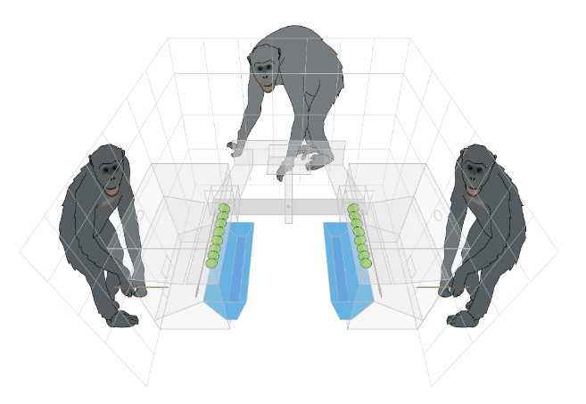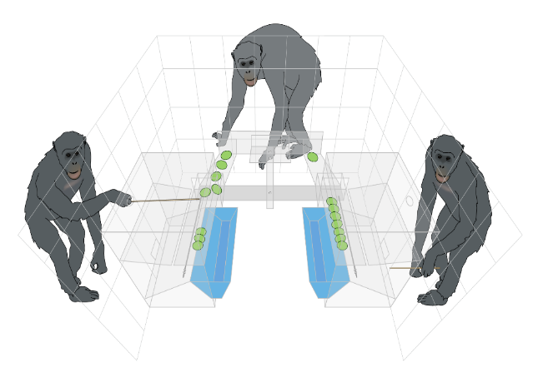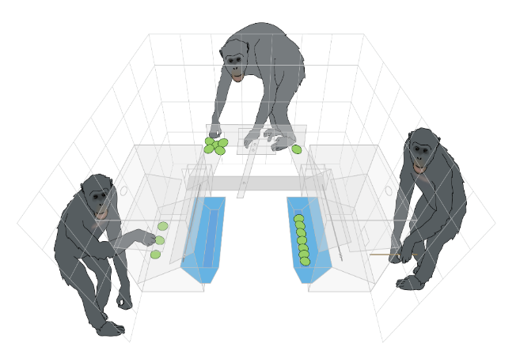

**Figure 1-3:** Representation of a triadic consecutive trial depicting the most relevant parts of the apparatus: In the top figure the left proposer offers 5 rewards. In the middle figure the responder accepts the offer of 5 rewards and rejects a previous one reward offer. In the bottom figure the responder obtains the 5 rewards and the accepted proposer obtains three rewards.

**Pre-test procedures:**

**Quantity control**

Every ape conducted an individual quantity control from the responders’ perspective. The quantity control consists of multiple sessions of eight trials each. Each trial presents the subjects with two options, varying in only one grape between them (all combinations from 0-1 grapes to 7-8 grapes). The rewards were placed on the left and right platforms of the responder side. The location of both options varied between sessions. The presentation type also varied between sessions: in half of the quantity control sessions, we presented the two options simultaneously, and in the other half of the sessions, we presented both options consecutively—the side of the first presented option changed every trial. To access the food, chimpanzees should use the sliding door to open their preferred side. Opening one side automatically blocked the access to the other side. In this way, chimpanzees could not obtain both options. Individuals should choose the biggest amount in at least 80% of trials in two consecutive sessions to pass the quantity control.

We noticed that some subjects had struggles with the procedure. In those cases, subjects participated in more accessible quantity control sessions. First, they participated in sessions with a difference of three rewards between the two food options (e.g., 5-8 rewards). These sessions included motivational trials in which individuals had to decide between zero and one, two, or three food rewards. After they succeeded in two consecutive sessions following the previous criteria, they participated in sessions with a difference of two rewards between food options (e.g., 4-6 rewards). These sessions also included motivational trials in which individuals decided between zero and one or two rewards. After they passed this phase, they returned to the original quantity controls for a maximum of eight consecutive sessions before they passed the criteria.

**Pre-test 1: experience food access from the responder side**

After assessing their quantity preferences, chimpanzees participated in individual sessions to learn how to make offers from the proposer’s perspective. That is, to send rewards from the proposer to the responder sides. They needed to learn how to manipulate approx. 40 cm wooden sticks as tools to make offers.

In this pre-test, the rewards were not baited on the platforms of the responder side, but on the flappable trays of the proposers’ sides. From each proposer side, they had to use the tool to send the grapes towards the responder side. Once they sent all the rewards, the experimenter unlocked the access to the responder side, where they could accept one of the two food offers by sliding the central door. This way, they experienced that only one of the offers became accessible.

We presented chimpanzees with six trials per session and three distinct options, each randomly presented once on every proposer side. Food options are 0-4, 2-4, and 4-6. To pass this control phase, chimpanzees should score at least 11 trials correctly over two consecutive sessions.

**Pre-test 2: experience food access from the proposer side**

In the last pre-test, chimpanzees experienced acceptance/rejection from the proposers’ sides. For that purpose, we presented them with the same scenario as in the previous control except that chimpanzees had no access to tools. As a result, the participants could not send rewards from the proposers to the responder side. Instead, subjects should assess the quantities on the top of the flappable trays before making a decision. Since the responder and the proposers’ sides were interconnected, subjects should slide the central door to flip the selected tray towards one of the proposers’ sides and thus access their preferred rewards. This way, chimpanzees could experience how to obtain the rewards that they did not send to the responder (e.g., the share of the rewards the proposers keep for themselves), and how to lose rewards when their offers were rejected. The structure of the sessions and the pass criteria were the same as in the first pre-test.

Afterwards, chimpanzees participated in test trials (see Study design). Triads were created based on the number of chimpanzees who passed the criteria and the animal keeper suggestions.

**Sample size**

Given previous pilot information and the fact that three individuals already passed all pre-test steps, we planned to test between 5 and 7 chimpanzees following the pre-registered method. Furthermore, given the difficulty that some apes experienced during the first pre-test, we anticipated that some individuals would only participate as responders in the final task. Finally, we tested 7 chimpanzees with two of them participating exclusively as responders.

**Sample size rationale**

We performed a simulation-based power analysis in order to assess whether our planned sample size (which is tightly constrained by practical considerations) is adequate to detect realistic differences in total responder rewards between the dyadic and triadic conditions. Such an analysis must necessarily be considered tentative given the difficulty of anticipating plausible effect sizes.

To simulate games, we defined a small number of strategies which might conceivably approximate the behaviour of any individual chimpanzee. The strategies are described below in a deterministic fashion, i.e., chimpanzees are described as accepting or rejecting offers according to particular rules which unambiguously prescribe a certain behaviour. However, in the simulations, all strategies were implemented probabilistically. Each chipmanzee has a “noise” parameter, sampled from a Normal distribution centred on 0.2 with standard deviation 0.05 (such that values are very likely to fall between 0.1 and 0.3) which dictates how closely they adhere to their strategy. A responder chimpanzee with a noise parameter of 0.25, for example, will make the decision dictated by their strategy on 75% of trials, but will “erroneously” make the opposite decision on the remaining 25% of trials. Similarly, a proposer chimpanzee will make the offer dictated by their strategy on a majority proportion of trials determined by noise parameter, but on a minority of trials will offer either one grape more or one grape fewer (with equal probability) than this value. Thus, multiple simulations of a game with the same assignment of strategies to participants will not all yield identical outcomes.

Separate responder strategies are defined for dyadic and triadic games due to the essential difference in the decision made (choosing whether to accept or reject a single offer, or choosing which, if any, of two distinct offers to accept). The same set of proposer strategies are used for dyadic and triadic games, with an additional mechanism used for triadic games where proposals are made consecutively. Each chimpanzee has an additional “competition awareness” parameter (set to TRUE or FALSE by an independent fair coin toss for each ape) which indicates whether or not they are sensitive to the additional competitive potential of the consecutive offer scenario. Chimpanzees who are “competition aware” and make the second offer of a consecutive trial will either offer the same number of grapes as the first proposer (so as not to be “out-offered”), or will offer one grape more than the first proposer (with equal probability). Chimpanzees who are “competition unaware” and make the second offer in a consecutive trial will ignore their co-proposer’s offer and act according to the same strategy they use in dyadic trials and when making the first offer of a consecutive trial.

For each separate simulation, every participating is assigned a dyadic proposer strategy, a dyadic responder strategy, a triadic responder strategy, a noise parameter (shared across all strategies) and a competition awareness parameter, which remain fixed for all games in the simulation. Chimpanzees use the same strategies and parameters for all the triads in which they participate. Due to the potential for interactions between the strategies of participating apes, this means that simulated apes may behave quite differently across different games within the same simulation, depending on who they are partnered with. A simulated ape who is competition aware may be paired with a co-proposer who is also competition aware in one simulated triad, potentially triggering an “arms race” across trials, while in another simulated triad they may be paired with a co-proposer who is competition unaware. Across many hundred simulated reproductions of our planned data collection, our power analysis will consider the outcome of sampling our planned number of datapoints from many different “worlds”. In some, the chimpanzees may be relatively homogeneous in their behaviours, so that all triads perform similarly, while in others apes may vary considerably, such that different triads lead to very different dynamics. In this way, the difference in total responder rewards between the dyadic and triadic conditions will be greater in some simulations and lesser in others, reflecting our underlying uncertainty about effect size. If our model can successfully detect a difference between dyadic and triadic conditions in the majority of simulated worlds, this provides some confidence that it is likely to succeed also in the real world.

All strategies are described below. These strategies are *not* intended as direct, literal hypotheses about what happens inside the mind of real world chimpanzees. More sophisticated strategies are naturally possible (and indeed likely), as is the prospect of participants changing strategies over time. Instead, these strategies are intended as principled, non-arbitrary tools to provide “ballpark” estimates of many quantities necessary for power analysis, such as the possible differences in total responder reward between dyadic and triadic conditions, the amount of variation within condition across triads, etc.

**Dyadic responder strategies:**

Rational Dyadic Responder: Accepts any non-zero offer – “anything is better than nothing”. This strategy is based on previous results with great apes (eg., Jensen et al., 2007).

Fairness Dyadic Responder: Accepts any offer where they get at least as much reward as the proposer – “I should forgo rewards to punish the greedy”.

No Decrease Dyadic Responder: Rejects initial offers of zero, and rejects any subsequent offer which is not at least as high as the highest previous offer in the same game – “I know you gave me *n* grapes once before, so I will never accept less than *n* again”.

**Triadic responder strategies:**

Rational Triadic Responder: Accepts the greatest of the two offers, choosing randomly if both offers are equal – “the more for me, the better”.

Fairness Triadic Responder: Does not distinguish between fair offers (i.e. those where the responder gets at least as many grapes as the proposer), choosing amongst such offers randomly. Acts as a Rational Dyadic Responder if unfair offers are involved – “I am more concerned with not being taken advantage of by a greedy proposer than I am with maximising my rewards”.

Maximum Generosity Responder: Accepts the offer of whichever proposer has offered the highest cumulative total of grapes across all rounds of the game so far, regardless of the current offers - “Your last minute generosity does not make up for consistent early stinginess”.

**Common proposer strategies (available for use in both dyadic and triadic games):**

Rational Proposer: Always offers a single grape, secure in the knowledge that a correspondingly Rational Responder will always accept this, leaving a large reward for the proposer.

Reluctantly Increasing Proposer: Each such proposer has a threshold number *n* of rejections (n=1 with p=0.8, n=2 with p=0.15, n=3 with p=0.05). They repeat their previous offer until this has been rejected (dyadic condition) or the other proposer’s offer chosen instead (triadic condition) a total of *n* times in a row, whereupon they increase their offer by one grape. The initial offer is a low offer of 1, 2 or 3 grapes (with the same probability distribution as n above). This strategy is based on the famous win-stays, lose-shifts game theory strategy by Nowak and Sigmund (Nowak & Sigmund, 1993).

**Triadic-only proposer strategies:**

Repeat Last Proposer: Makes a low initial offer as per the Reluctantly Increasing Proposer. For all subsequent rounds, offers the same amount that the responder accepted on the previous round – “You accepted this many grapes last time, you should accept them again”.

We performed a total of 500 simulations, each involving seven simulated apes organised into seven triads according to constraints inferred from the performance of actual apes in pre-testing phases, i.e. that two apes would be unable to play the role of proposer. The seven triads were carefully structured so as to minimise variation in the degree of similarity between pairs of triads. There are 21 distinct pairs of triads. 11 of these pairs have a single ape in common, while two pairs have no overlap at all. The remaining 8 pairs have two apes in common – in three of these cases, both apes play different roles in the two triads.

The model described below was applied to all 500 simulated datasets (the experience variable was omitted, as the strategies used in our simulations were incapable of producing genuine effects of experience). In 431 of these analyses, a difference between the dyadic and triadic games was inferred with high confidence (as per the description below), giving an estimated power of 0.86, above the conventional threshold of 0.80.

Note that a detectable difference in proposer’s offers between the dyadic and triadic conditions does not necessarily imply an understanding of the proposers that they are participating in a competitive scenario. For example, two proposers who pay no attention to each other’s offers and act simply as Reluctantly Increasing Proposers may, when paired with a rational responder, end up increasing their offers, even if both make equal initial offers. If the randomly choosing responder happens to accept one proposer’s offers sufficiently many times in a row to cause the other proposer to increase their offer, the responder will “switch sides”, eventually causing the other proposer to increase their offer, at which point both proposers are making equal offers and the initial dynamic may repeat. Therefore, we perform a second power analysis focussed on detecting a difference between consecutive and simultaneous tryadic trials, based only on the first 4 rounds of each sessions. Such an effect can only be reasonably explained via competitive reasoning on the part of participants. Again we performed 500 simulations, and an effect of consecutive vs simultaneous trial structure was found in XX analyses, giving an estimated power of 0.YY.

**Variables**

**Test variables**

**Triadic vs. dyadic condition: Two chimpanzees make offers to a responder in triadic sessions. The responder has the chance to accept one of the two offers. In dyadic sessions, only one proposer makes an offer within a trial.**

**Nested within triadic sessions are consecutive and simultaneous trials. In consecutive trials, proposers make their offers consecutively, with the starting order changing every two trials. In simultaneous trials, both proposers make their offers at the same time.**

**Control variables**

**Experience – the combined number of previously completed sessions by all members of a triad.**

**Dependent measure**

The dependent measure is the total quantity of grapes offered by a given proposer at the end of a session block, expressed as a proportion of the maximum possible offer of 64 (or 32 for the “first half” analyses).

**Analysis Plan**

**Representation of the statistical models**

We will fit two models to the data, both of which use a Beta distribution (with the mean/precision parameterisation commonly used for GLMMs) to model the proportion of maximum possible reward offered by a proposer (i.e. offered number of grapes divided by maximum possible offer). In both models, both the mean and precision of the Beta distribution is allowed to vary between dyadic and triadic games.

One model is applied to the full set of data, i.e. in each session the maximum possible offer is 64 (8 grapes in each of 8 rounds). After fitting this model, we will compute 90% highest posterior density intervals for the differences in mean and precision between the two conditions. If either of these intervals excludes zero we will interpret this as strong evidence for a difference in proposer behaviour between the two conditions.

The other model is applied only to the “first half” of the data, i.e. to the first 4 rounds of each session, so that the maximum possible offer is reduced to 32. With this restriction of the data, each triadic session consists of either entirely simultaneous or entirely consecutive rounds. This model therefore includes an additional predictor variable, which takes the value 0 for dyadic rounds, -0.5 for simultaneous triadic rounds and 0.5 for consecutive triadic rounds. The value of the corresponding “slope” parameter therefore has no effect on the fit to dyadic round data, but can capture a difference in either mean of precision between simultaneous and consecutive triadic rounds.

Both models account for random variation across triads and systematic variation with the experience of the subjects. Only random effects of triad are included, without corresponding effects of the responder or proposer(s), as the limited number of unique triads precludes the reliable separation – in particular, no participant acts as the responder in more than one triad.

The full model specification is given below in a unified form:

* The response variable yij is the proportion of total possible offer offered by the ith proposer in their jth session
* ti is the triad to which the ith proposer belongs
* gij takes the value 0 or 1 according to whether or not the ith proposer’s jth session is a dyadic (0) or triadic (1) game, and is used to index the two mean and precision variables μ0 and μ1 and ϕ0 and ϕ1 (and their corresponding random effects).
* hij takes the value 0 for dyadic sessions, -0.5 for triadic sessions featuring simultaneous presentation of offers and 0.5 for triadic sessions featuring a consecutive presentation of offers – the corresponding “slope” parameter β0 therefore represents the effect of simultaneous vs. consecutive presentation. Adding or removing all hij terms from the model below transforms between the two models described above.
* xij indicates the total number of previous sessions completed by participant i at the time of the jth session – the corresponding “slope” parameter β1 therefore represents the effect of experience.

yij ~ Beta(μij, ϕij)

μij = logit-1(μgij + ugij,i + vgij,ti + (β0 + wti)hij + (β1 + 𝜔i)xij)

μk ~ N(-1, 1.5), k = 0, 1

β0 ~ N(0, 0.75)

β1 ~ N(0, 0.10)

ϕij ~ exp(ϕgij + β2hij + v’ti))

ϕk ~ N(5, 2.5), k = 0, 1

β2 ~ N(0, 1.5)

u., v., w., 𝜔., v’. ~ N(0, σ.)

σ. ~ Exponential(5)